**PROJECT TITLE: Hazardous Area Monitoring for Industrial Plant.**

**PROJECT DESIGN PHASE -I** - **Solution Fit DATE:27/09/2022.**

**Team ID:** PNT2022TMID41953.

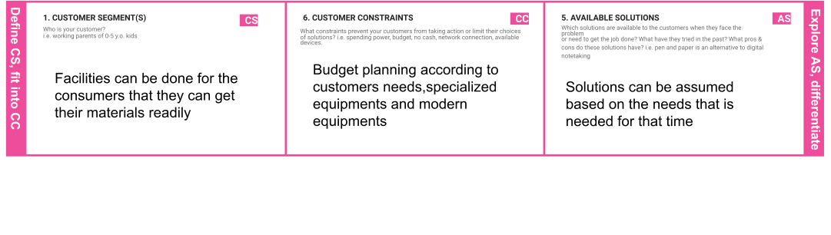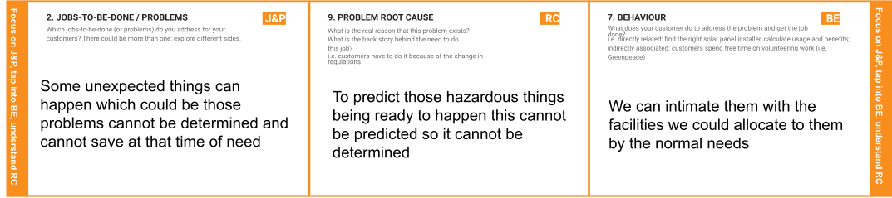

|  |  |  |  |  |  |  |
| --- | --- | --- | --- | --- | --- | --- |
|  | **3. TRIGGERS**  What triggers customers to act? i.e. seeing their neighbour installing solar panels, reading about a more efficient solution in the news.  **Using the appropriate resources customers can get the information** | **TR** | **10. YOUR SOLUTION SL**  If you are working on an existing business, write down your current solution first, fill in the canvas, and check how much it fits reality.  If you are working on a new business proposition, then keep it blank until you fill in the canvas and come up with a solution that fits within customer limitations, solves a problem and matches customer behavior.  **Have all the available things to be taken**  **and precautions to be taken to avoid the danger** | **8.CHANNELS of BEHAVIOR**  **8.1ONLINE**  What kind of actions do customers take online? Extract online channels from #7  **Find the necessary resources to be taken and take available things to access**  **8.2OFFLINE**  What kind of actions do customers take offline? Extract offline channels from #7 and use them for customer development.  **Check for the things to provide betterment** | **CH** |  |

|  |  |  |  |  |
| --- | --- | --- | --- | --- |
|  | **4. EMOTIONS: BEFORE / AFTER EM**  How do customers feel when they face a problem or a job and afterwards?  ie. lost, insecure > confident, in control - use it in your communication strategy & design.  **Before:**  **Equipped resources fear Not confident about the things to be taken measures**  **After:**  **Growing technologies have been done for the things to handle efficiently** |  |  |  |